

**МІНІСТЕРСТВО ОСВІТИ І НАУКИ УКРАЇНИ**

**ННК «ІПСА» НТУУ «КПІ ІМ. ІГОРЯ СІКОРСЬКОГО» КАФЕДРА ММСА**

**Практична робота № 3**

**З курсу:** «**Комп’ютерні мережі**»

**Виконала: Студентка ІIІ курсу**

**Групи КА-73 Колесник М.М.**

**Прийняв: Кухарєв С.О.**

**Київ 2020**

# 3.2.1

No. Time Source Destination Protocol Length Info

60 20.589855 192.168.0.106 192.168.0.1 DNS 72 Standard

query 0x5ee0 A [www.ietf.org](http://www.ietf.org/)

Frame 60: 72 bytes on wire (576 bits), 72 bytes captured (576 bits) on interface en0, id 0

Ethernet II, Src: Apple_78:53:31 (f0:18:98:78:53:31), Internet Protocol Version 4, Src: 192.168.0.106, Dst: User Datagram Protocol, Src Port: 52943, Dst Port: 53 Domain Name System (query)

Dst: Tp-LinkT_66:88:6a (ac:84:c6:66:88:6a) 192.168.0.1

No. Questions: 1

Answer RRs: 0

Authority RRs: 0

Additional RRs: 0 Queries

[www.ietf.org:](http://www.ietf.org/) type A, class IN Name: [www.ietf.org](http://www.ietf.org/) [Name Length: 12]

[Label Count: 3]

Type: A (Host Address) (1) Class: IN (0x0001)

[Response In: 62]

Time Source

61 21.593510 192.168.0.106

Destination 192.168.0.1

Protocol Length Info DNS 72 Standard Transaction ID: 0x5ee0

Flags: 0x0100 Standard query

0... .... .000 0... .... ..0. .... ...1 .... .... .... ....

.... .... = Response: Message is a query

.... .... = Opcode: Standard query (0)

.... .... = Truncated: Message is not truncated .... .... = Recursion desired: Do query recursively .0.. ....

= Z: reserved (0)

...0 = Non-authenticated data: Unacceptable

query 0x5ee0 A [www.ietf.org](http://www.ietf.org/)

Frame 61: 72 bytes on wire (576 bits), 72 bytes captured (576 bits) on interface en0, id 0

Ethernet II, Src: Apple_78:53:31 (f0:18:98:78:53:31), Internet Protocol Version 4, Src: 192.168.0.106, Dst: User Datagram Protocol, Src Port: 52943, Dst Port: 53 Domain Name System (query)

Dst: Tp-LinkT_66:88:6a (ac:84:c6:66:88:6a) 192.168.0.1

No.

Questions: 1

Answer RRs: 0

Authority RRs: 0

Additional RRs: 0 Queries

[www.ietf.org:](http://www.ietf.org/) type A, class IN Name: [www.ietf.org](http://www.ietf.org/) [Name Length: 12]

[Label Count: 3]

Type: A (Host Address) (1) Class: IN (0x0001)

[Retransmitted request. Original request in: 60] [Retransmission: True]

Time Source Destination 62 21.670330 192.168.0.1 192.168.0.106 Protocol Length Info

Transaction ID: 0x5ee0

Flags: 0x0100 Standard query

0... .... .000 0... .... ..0. .... ...1 .... .... .... ....

.... .... = Response: Message is a query

.... .... = Opcode: Standard query (0)

.... .... = Truncated: Message is not truncated .... .... = Recursion desired: Do query recursively .0.. ....

= Z: reserved (0)

...0 = Non-authenticated data: Unacceptable

DNS 459 Standard query response 0x5ee0 A [www.ietf.org](http://www.ietf.org/) CNAME [www.ietf.org.cdn.cloudflare.net](http://www.ietf.org.cdn.cloudflare.net/) A 104.20.0.85 A

* + - 1. NS ns1.cloudflare.net NS ns4.cloudflare.net NS ns2.cloudflare.net NS ns3.cloudflare.net NS ns5.cloudflare.net A 173.245.59.31 AAAA 2400:cb00:2049:1::adf5:3b1f A 198.41.222.131 AAAA 2400:cb00:2049:1::c629:de83 A 198.41.222.31 AAAA 2400:cb00:2049:1::c629:de1f A

198.41.223.131 AAAA 2400:cb00:2049:1::c629:df83 A 198.41.223.31 AAAA

2400:cb00:2049:1::c629:df1f

Frame 62: 459 bytes on wire (3672 bits), 459 bytes captured (3672 bits) on interface en0, id 0 Ethernet II, Src: Tp-LinkT_66:88:6a (ac:84:c6:66:88:6a), Dst: Apple_78:53:31 (f0:18:98:78:53:31)

/Users/mariia/Desktop/dump1.pcapng 6667 total packets, 7 shown

Internet Protocol Version 4, Src: 192.168.0.1, Dst: 192.168.0.106 User Datagram Protocol, Src Port: 53, Dst Port: 52943

Domain Name System (response)

Transaction ID: 0x5ee0

Flags: 0x8180 Standard query response, No error

1... .... .... .... .000 0... .... .... .... .0.. .... .... .... ..0. .... .... .... ...1 .... .... .... .... 1... .... .... .... .0.. .... .... ....

..0. ....

authenticated by the server .... .... ...0 ....

= Response: Message is a response

= Opcode: Standard query (0)

= Authoritative: Server is not an authority for domain

= Truncated: Message is not truncated

= Recursion desired: Do query recursively

= Recursion available: Server can do recursive queries

= Z: reserved (0)

= Answer authenticated: Answer/authority portion was not

= Non-authenticated data: Unacceptable = Reply code: No error (0)

.... .... .... 0000 Questions: 1

Answer RRs: 3

Authority RRs: 5

Additional RRs: 10 Queries

[www.ietf.org:](http://www.ietf.org/) type A, class IN Name: [www.ietf.org](http://www.ietf.org/) [Name Length: 12]

[Label Count: 3]

Type: A (Host Address) (1) Class: IN (0x0001)

Answers

Authoritative nameservers Additional records [Request In: 60] [Time: 1.080475000

Ethernet II, Src: Apple_78:53:31 (f0:18:98:78:53:31), Internet Protocol Version 4, Src: 192.168.0.106, Dst: User Datagram Protocol, Src Port: 55217, Dst Port: 53 Domain Name System (query)

No.

seconds] Source

192.168.0.106 192.168.0.1 DNS 78 Standard

Destination

Frame 346: 78 bytes on wire (624 bits), 78 bytes captured (624 bits) on interface en0, id 0

Time

346 22.780675

Protocol Length Info

query 0xc3f6 A analytics.ietf.org No.

Questions: 1

Answer RRs: 0

Authority RRs: 0

Additional RRs: 0 Queries

analytics.ietf.org: type A, class IN Name: analytics.ietf.org [Name Length: 18]

[Label Count: 3]

Type: A (Host Address) (1) Class: IN (0x0001)

[Response In: 545]

Time Source

545 23.016499 192.168.0.1

Destination

Protocol Length Info Transaction ID: 0xc3f6

Flags: 0x0100 Standard query

0... .... .000 0... .... ..0. .... ...1 .... .... .... ....

.... .... = Response: Message is a query

.... .... = Opcode: Standard query (0)

.... .... = Truncated: Message is not truncated .... .... = Recursion desired: Do query recursively .0.. ....

= Z: reserved (0)

...0 = Non-authenticated data: Unacceptable

192.168.0.106

query response 0xc3f6 A analytics.ietf.org CNAME ietf.org A 4.31.198.44 NS ns1.ams1.afilias-

nst.info NS ns1.mia1.afilias-nst.info NS ns0.amsl.com NS ns1.yyz1.afilias-nst.info NS ns1.sea1.afilias-nst.info NS ns1.hkg1.afilias-nst.info A 4.31.198.40 AAAA 2001:1900:3001:11::28 A 65.22.6.79 AAAA 2001:500:6::79 A 65.22.6.1 AAAA 2a01:8840:6::1 A 65.22.7.1 AAAA

2a01:8840:7::1 A 65.22.8.1 AAAA 2a01:8840:8::1 A 65.22 9.1 AAAA 2a01:8840:9::1

Dst: Tp-LinkT_66:88:6a (ac:84:c6:66:88:6a) 192.168.0.1

DNS 529 Standard

/Users/mariia/Desktop/dump1.pcapng 6667 total packets, 7 shown

Frame 545: 529 bytes on wire (4232 bits), 529 bytes captured (4232 bits) on interface en0, id 0 Ethernet II, Src: Tp-LinkT_66:88:6a (ac:84:c6:66:88:6a), Dst: Apple_78:53:31 (f0:18:98:78:53:31) Internet Protocol Version 4, Src: 192.168 0.1, Dst: 192.168.0.106

User Datagram Protocol, Src Port: 53, Dst Port: 55217

Domain Name System (response) Transaction ID: 0xc3f6

Flags: 0x8180 Standard query response, No error

1... .... .... .... .000 0... .... .... .... .0.. .... .... .... ..0. .... .... .... ...1 .... .... .... .... 1... .... .... .... .0.. .... .... ....

..0. ....

authenticated by the server

* + - * + .... .... ...0 ....
        + 0000 Questions: 1
        + Answer RRs: 2
        + Authority RRs: 6
        + Additional RRs: 12
        + Queries

analytics.ietf.org:

Name: analytics.ietf.org [Name Length: 18] [Label Count: 3]

Type: A (Host Address) (1) Class: IN (0x0001)

Answers

Authoritative nameservers Additional records [Request In: 346] [Time: 0.235824000

= Response: Message is a response

= Opcode: Standard query (0)

= Authoritative: Server is not an authority for domain

= Truncated: Message is not truncated

= Recursion desired: Do query recursively

= Recursion available: Server can do recursive queries

= Z: reserved (0)

= Answer authenticated: Answer/authority portion was not

= Non-authenticated data: Unacceptable = Reply code: No error (0) type A, class IN

seconds] Source

192.168.0.106 192.168.0.1 DNS 96 Standard

Protocol Length Info

Frame 3167: 96 bytes on wire (768 bits), 96 bytes captured (768 bits) on interface en0, id 0

No. Time 3167 25.322207

Destination

query 0x40ba A ss-prod-ew1-notif-26.aws.adobess.com

Ethernet II, Src: Apple_78:53:31 (f0:18:98:78:53:31), Internet Protocol Version 4, Src: 192.168.0.106, Dst: User Datagram Protocol, Src Port: 61123, Dst Port: 53 Domain Name System (query)

Dst: Tp-LinkT_66:88:6a (ac:84:c6:66:88:6a) 192.168.0.1

No.

Type: A (Host Address) (1) Class: IN (0x0001)

[Response In: 3169]

Time Source 3169 25.331050 192.168.0.1

Destination

Protocol Length Info Transaction ID: 0x40ba

Flags: 0x0100 Standard query

0... .... .000 0... .... ..0. .... ...1 .... .... .... ....

.... .... = Response: Message is a query

.... .... = Opcode: Standard query (0)

.... .... = Truncated: Message is not truncated .... .... = Recursion desired: Do query recursively .0.. ....

= Z: reserved (0)

...0 = Non-authenticated data: Unacceptable

Questions: 1

Answer RRs: 0

Authority RRs: 0

Additional RRs: 0 Queries

ss-prod-ew1-notif-26.aws.adobess.com: type A, class IN Name: ss-prod-ew1-notif- 26.aws.adobess.com

[Name Length: 36]

[Label Count: 4]

192.168.0.106

query response 0x40ba A ss-prod-ew1-notif-26.aws.adobess.com A 52.31 117.171 A 18.202.149.73

A

18.203.76.53 NS ns-1000.awsdns-61.net NS ns-1676.awsdns-17.co.uk NS ns-445.awsdns-55.com NS ns-1326.awsdns-37.org A 205.251 193.189 A 205.251.195.232

DNS 314 Standard

/Users/mariia/Desktop/dump1.pcapng 6667 total packets, 7 shown

Frame 3169: 314 bytes on wire (2512 bits), 314 bytes captured (2512 bits) on interface en0, id 0 Ethernet II, Src: Tp-LinkT_66:88:6a (ac:84:c6:66:88:6a), Dst: Apple_78:53:31 (f0:18:98:78:53:31) Internet Protocol Version 4, Src: 192.168 0.1, Dst: 192.168.0.106

User Datagram Protocol, Src Port: 53, Dst Port: 61123

Domain Name System (response) Transaction ID: 0x40ba

Flags: 0x8180 Standard query response, No error

1... .... .... .... .000 0... .... .... .... .0.. .... .... .... ..0. .... .... .... ...1 .... .... .... .... 1... .... .... .... .0.. .... .... ....

..0. ....

authenticated by the server .... .... ...0 ....

.... .... .... 0000 Questions: 1

Answer RRs: 3

Authority RRs: 4

Additional RRs: 2 Queries

= Response: Message is a response

= Opcode: Standard query (0)

= Authoritative: Server is not an authority for domain

= Truncated: Message is not truncated

= Recursion desired: Do query recursively

= Recursion available: Server can do recursive queries

= Z: reserved (0)

= Answer authenticated: Answer/authority portion was not

= Non-authenticated data: Unacceptable = Reply code: No error (0)

ss-prod-ew1-notif-26.aws.adobess.com: type A, class IN Name: ss-prod-ew1-notif- 26.aws.adobess.com

[Name Length: 36]

[Label Count: 4]

Type: A (Host Address) (1) Class: IN (0x0001)

Answers

Authoritative nameservers Additional records [Request In: 3167] [Time: 0.008843000 seconds]

# 3.2.2

No. Time Source Destination Protocol Length Info

9 0.622283 192.168.0.106 192.168.0.1 DNS 77 Standard

query 0x3691 A polka.typekit.com

Frame 9: 77 bytes on wire (616 bits), 77 bytes captured (616 bits) on interface en0, id 0 Ethernet II, Src: Apple_78:53:31 (f0:18:98:78:53:31), Dst: Tp-LinkT_66:88:6a (ac:84:c6:66:88:6a) Internet Protocol Version 4, Src: 192.168.0.106, Dst: 192.168.0.1

User Datagram Protocol, Src Port: 61610, Dst Port: 53 Domain Name System (query)

No.

Transaction ID: 0x3691

Flags: 0x0100 Standard query Questions: 1

Answer RRs: 0

Authority RRs: 0

Additional RRs: 0 Queries [Response In: 11]

Source Destination Protocol

Length Info 390 Standard 34.199.93.198 A No.

Time Source

69 12.965187 192.168.0.106

Destination 192.168.0.1

Protocol Length Info DNS 71 Standard

No.

Transaction ID: 0x075a

Flags: 0x0100 Standard query Questions: 1

Answer RRs: 0

Authority RRs: 0

Additional RRs: 0 Queries [Response In: 70]

Source Destination

Protocol Length Info

Time

11 0.660230

192.168.0.1

query response 0x3691 A polka.typekit.com A 34.195.21.71 A 34.225.200.117 A

Transaction ID: 0x3691

Flags: 0x8180 Standard query response, No error Questions: 1 Answer RRs: 8

Authority RRs: 4

Additional RRs: 3 Queries

Answers

Authoritative nameservers Additional records [Request In: 9]

[Time: 0.037947000 seconds]

192.168.0.106

DNS

34.199.238.234 A 34.195.121.224 A 34.203.172.63 A 34.202.173.107 A 34.206.199.72 NS ns-

964.awsdns-56.net NS ns-342.awsdns-42.com NS ns-1561.awsdns-03.co.uk NS ns-1260.awsdns- 29.org A 205.251.193.86 A 205.251.195.196 A 205.251.196.236

Frame 11: 390 bytes on wire (3120 bits), 390 bytes captured (3120 bits) on interface en0, id 0 Ethernet II, Src: Tp-LinkT_66:88:6a (ac:84:c6:66:88:6a), Dst: Apple_78:53:31 (f0:18:98:78:53:31) Internet Protocol Version 4, Src: 192.168.0.1, Dst: 192.168.0.106

User Datagram Protocol, Src Port: 53, Dst Port: 61610 Domain Name System (response)

query 0x075a A [www.mit.edu](http://www.mit.edu/)

Frame 69: 71 bytes on wire (568 bits), 71 bytes captured (568 bits) on interface en0, id 0 Ethernet II, Src: Apple_78:53:31 (f0:18:98:78:53:31), Dst: Tp-LinkT_66:88:6a (ac:84:c6:66:88:6a) Internet Protocol Version 4, Src: 192.168.0.106, Dst: 192.168.0.1

User Datagram Protocol, Src Port: 65377, Dst Port: 53 Domain Name System (query)

Time

70 13.002524

192.168.0.1

query response 0x075a A [www.mit.edu](http://www.mit.edu/) CNAME [www.mit.edu.edgekey.net](http://www.mit.edu.edgekey.net/) CNAME

e9566.dscb.akamaiedge.net A 92.123.2.59 NS n3dscb.akamaiedge.net NS n5dscb.akamaiedge.net NS n6dscb.akamaiedge.net NS n7dscb.akamaiedge.net NS n0dscb.akamaiedge.net NS n4dscb.akamaiedge.net NS n2dscb.akamaiedge.net NS n1dscb.akamaiedge.net A 88.221.81.192 AAAA 2600:1480:e800::c0 A 104.94.100.70 A 104.94.100.94 A 104.94.100.29 A 104.94.100.93 A

104.94.100.132 A 95.101.23.214 A 2.16.10.190

Frame 70: 484 bytes on wire (3872 bits), 484 bytes captured (3872 bits) on interface en0, id 0 Ethernet II, Src: Tp-LinkT_66:88:6a (ac:84:c6:66:88:6a), Dst: Apple_78:53:31 (f0:18:98:78:53:31) Internet Protocol Version 4, Src: 192.168.0.1, Dst: 192.168.0.106

User Datagram Protocol, Src Port: 53, Dst Port: 65377 192.168.0.106

DNS 484 Standard

/Users/mariia/Desktop/dump2.pcapng 164 total packets, 8 shown

Domain Name System (response) Transaction ID: 0x075a

Flags: 0x8180 Standard query response, No error Questions: 1 Answer RRs: 3

Authority RRs: 8

Additional RRs: 9 Queries

Answers

Authoritative nameservers Additional records [Request In: 69]

[Time: 0.037337000

No. Time

72 13.364475

query 0x6e6b A mail.ukr.net

Frame 72: 72 bytes on wire (576 bits), 72 bytes captured (576 bits) on interface en0, id 0 Ethernet II, Src: Apple_78:53:31 (f0:18:98:78:53:31), Dst: Tp-LinkT_66:88:6a (ac:84:c6:66:88:6a) Internet Protocol Version 4, Src: 192.168.0.106, Dst: 192.168.0.1

User Datagram Protocol, Src Port: 57339, Dst Port: 53 Domain Name System (query)

No.

Transaction ID: 0x6e6b

Flags: 0x0100 Standard query Questions: 1

Answer RRs: 0

Authority RRs: 0

Additional RRs: 0 Queries [Response In: 74]

Source Destination

Protocol Length Info

Time

74 13.591777

seconds] Source

192.168.0.106 192.168.0.1 DNS 72 Standard

Destination

Protocol Length Info 192.168.0.1

query response 0x6e6b A mail.ukr.net A 212.42.75.249 NS ns2.fwdcdn.net NS ns1.fwdcdn.net A

212.42.82.100 A 212.42.77.100

Frame 74: 163 bytes on wire (1304 bits), 163 bytes captured (1304 bits) on interface en0, id 0 Ethernet II, Src: Tp-LinkT_66:88:6a (ac:84:c6:66:88:6a), Dst: Apple_78:53:31 (f0:18:98:78:53:31) Internet Protocol Version 4, Src: 192.168.0.1, Dst: 192.168.0.106

User Datagram Protocol, Src Port: 53, Dst Port: 57339 Domain Name System (response)

No.

seconds] Source

192.168.0.106 192.168.0.1 DNS 96 Standard

Transaction ID: 0x6e6b

Flags: 0x8180 Standard query response, No error Questions: 1 Answer RRs: 1

Authority RRs: 2

Additional RRs: 2 Queries

Answers

Authoritative nameservers Additional records [Request In: 72]

[Time: 0.227302000

Time

125 17.439749

192.168.0.106

DNS 163 Standard Destination

Protocol Length Info

query 0x090d A ss-prod-ew1-notif-26.aws.adobess.com

Frame 125: 96 bytes on wire (768 bits), 96 bytes captured (768 bits) on interface en0, id 0 Ethernet II, Src: Apple_78:53:31 (f0:18:98:78:53:31), Dst: Tp-LinkT_66:88:6a (ac:84:c6:66:88:6a) Internet Protocol Version 4, Src: 192.168.0.106, Dst: 192.168.0.1

User Datagram Protocol, Src Port: 52409, Dst Port: 53 Domain Name System (query)

Transaction ID: 0x090d

Flags: 0x0100 Standard query Questions: 1

Answer RRs: 0

Authority RRs: 0

Additional RRs: 0 Queries [Response In: 127]

No. Time Source Destination

Protocol Length Info

/Users/mariia/Desktop/dump2.pcapng 164 total packets, 8 shown

127 17.450149 192.168.0.1 192.168.0.106 DNS 314 Standard query response 0x090d A ss-prod-

ew1-notif-26.aws.adobess.com A 18.202.149.73 A 52.31.117.171 A 18.203.76.53 NS ns-445.awsdns- 55.com NS ns-1326.awsdns-37.org NS ns-1000.awsdns-61.net NS ns-1676.awsdns-17.co.uk A 205.251.193.189 A 205.251.195.232

Frame 127: 314 bytes on wire (2512 bits), 314 bytes captured (2512 bits) on interface en0, id 0 Ethernet II, Src: Tp-LinkT_66:88:6a (ac:84:c6:66:88:6a), Dst: Apple_78:53:31 (f0:18:98:78:53:31) Internet Protocol Version 4, Src: 192.168.0.1, Dst: 192.168.0.106

User Datagram Protocol, Src Port: 53, Dst Port: 52409 Domain Name System (response)

Transaction ID: 0x090d

Flags: 0x8180 Standard query response, No error Questions: 1 Answer RRs: 3

Authority RRs: 4

Additional RRs: 2 Queries

Answers

Authoritative nameservers Additional records [Request In: 125]

[Time: 0.010400000 seconds]

# 3.2.3

No. Time Source Destination Protocol Length Info

35 4.744495 192.168.0.106 192.168.0.1 DNS 67 Standard

query 0x631a A mit.edu

Frame 35: 67 bytes on wire (536 bits), 67 bytes captured (536 bits) on interface en0, id 0 Ethernet II, Src: Apple_78:53:31 (f0:18:98:78:53:31), Dst: Tp-LinkT_66:88:6a (ac:84:c6:66:88:6a) Internet Protocol Version 4, Src: 192.168.0.106, Dst: 192.168.0.1

User Datagram Protocol, Src Port: 51297, Dst Port: 53 Domain Name System (query)

No.

Transaction ID: 0x631a

Flags: 0x0100 Standard query Questions: 1

Answer RRs: 0

Authority RRs: 0

Additional RRs: 0 Queries [Response In: 36]

Source Destination

Protocol Length Info No.

Destination

Protocol Length Info DNS 70 Standard

Time

36 4.801817

192.168.0.1

query response 0x631a A mit.edu A 23.37.44.254 NS eur5.akam.net NS ns1-173.akam.net NS

ns1-37.akam.net NS use2.akam.net NS use5.akam.net NS asia1.akam.net NS usw2.akam.net NS asia2.akam.net A 23.74.25.64 A 96.7.49.64 A 184.26.161.64 A 95.100.175.64 A 95.101.36.64

Frame 36: 330 bytes on wire (2640 bits), 330 bytes captured (2640 bits) on interface en0, id 0 Ethernet II, Src: Tp-LinkT_66:88:6a (ac:84:c6:66:88:6a), Dst: Apple_78:53:31 (f0:18:98:78:53:31) Internet Protocol Version 4, Src: 192.168.0.1, Dst: 192.168.0.106

User Datagram Protocol, Src Port: 53, Dst Port: 51297 Domain Name System (response)

Transaction ID: 0x631a

Flags: 0x8180 Standard query response, No error Questions: 1

Answer RRs: 1

Authority RRs: 8

Additional RRs: 5 Queries

Answers

mit.edu: type A, class IN, addr 23.37.44.254 Authoritative nameservers

mit.edu: type NS, class IN, ns eur5.akam.net mit.edu: type NS, class IN, ns ns1-173.akam.net mit.edu: type NS, class IN, ns ns1-37.akam.net mit.edu: type NS, class IN, ns use2.akam.net mit.edu: type NS, class IN, ns use5.akam.net mit.edu: type NS, class IN, ns asia1.akam.net mit.edu: type NS, class IN, ns usw2.akam.net mit.edu: type NS, class IN, ns asia2.akam.net

Additional records eur5.akam.net: use2.akam.net: usw2.akam.net:

type A, class IN, addr 23.74.25.64 type A, class IN, addr 96.7.49.64 type A, class IN, addr 184.26.161.64

asia1.akam.net: type A,

asia2.akam.net: type A, [Request In: 35] [Time: 0.057322000 seconds]

Time Source

37 4.804571 192.168.0.106 23.37.44.254

192.168.0.106

DNS 330 Standard

class IN, addr 95.100.175.64 class IN, addr 95.101.36.64 query 0xb0c5 A –type=NS

Frame 37: 70 bytes on wire (560 bits), 70 bytes captured (560 bits) on interface en0, id 0 Ethernet II, Src: Apple_78:53:31 (f0:18:98:78:53:31), Dst: Tp-LinkT_66:88:6a (ac:84:c6:66:88:6a) Internet Protocol Version 4, Src: 192.168.0.106, Dst: 23.37.44.254

User Datagram Protocol, Src Port: 59228, Dst Port: 53 Domain Name System (query)

Transaction ID: 0xb0c5

Flags: 0x0100 Standard query Questions: 1

Answer RRs: 0

Authority RRs: 0

Additional RRs: 0 Queries

/Users/mariia/Desktop/dump3.pcapng 133 total packets, 5 shown

No. Time Source Destination Protocol Length Info

52 9.809429 192.168.0.106 23.37.44.254 DNS 70 Standard

query 0xb0c5 A –type=NS

Frame 52: 70 bytes on wire (560 bits), 70 bytes captured (560 bits) on interface en0, id 0 Ethernet II, Src: Apple_78:53:31 (f0:18:98:78:53:31), Dst: Tp-LinkT_66:88:6a (ac:84:c6:66:88:6a) Internet Protocol Version 4, Src: 192.168.0.106, Dst: 23.37.44.254

User Datagram Protocol, Src Port: 59228, Dst Port: 53 Domain Name System (query)

No. Time

85 14.811855

Source

Destination 23.37.44.254

Protocol Length Info DNS 70 Standard Transaction ID: 0xb0c5

Flags: 0x0100 Standard query Questions: 1

Answer RRs: 0

Authority RRs: 0

Additional RRs: 0 Queries

192.168.0.106 query 0xb0c5 A –type=NS

Frame 85: 70 bytes on wire (560 bits), 70 bytes captured (560 bits) on interface en0, id 0 Ethernet II, Src: Apple_78:53:31 (f0:18:98:78:53:31), Dst: Tp-LinkT_66:88:6a (ac:84:c6:66:88:6a) Internet Protocol Version 4, Src: 192.168.0.106, Dst: 23.37.44.254

User Datagram Protocol, Src Port: 59228, Dst Port: 53 Domain Name System (query)

Transaction ID: 0xb0c5

Flags: 0x0100 Standard query Questions: 1

Answer RRs: 0

Authority RRs: 0

Additional RRs: 0 Queries

# 3.2.4

No. Time Source Destination Protocol Length Info

5 2.042217 192.168.0.106 192.168.0.1 DNS 90 Standard

query 0xc45e A nexusrules.officeapps.live.com

Frame 5: 90 bytes on wire (720 bits), 90 bytes captured (720 bits) on interface en0, id 0 Ethernet II, Src: Apple_78:53:31 (f0:18:98:78:53:31), Dst: Tp-LinkT_66:88:6a (ac:84:c6:66:88:6a) Internet Protocol Version 4, Src: 192.168.0.106, Dst: 192.168.0.1

User Datagram Protocol, Src Port: 61102, Dst Port: 53 Domain Name System (query)

No.

Transaction ID: 0xc45e

Flags: 0x0100 Standard query Questions: 1

Answer RRs: 0

Authority RRs: 0

Additional RRs: 0 Queries [Response In: 7]

Time

7 2.084037

Transaction ID: 0xc45e

Flags: 0x8180 Standard query response, No error Questions: 1

Answer RRs: 2

Authority RRs: 10

Additional RRs: 5 Queries

Answers

nexusrules.officeapps.live.com: type CNAME, class IN, cname prod.nexusrules.live.com.akadns.net Source

Destination

Protocol Length Info

192.168.0.1

query response 0xc45e A nexusrules.officeapps.live.com CNAME prod.nexusrules.live.com.akadns.net A 52.109.120.17 NS a5-130.akagtm.org NS a11-129.akadns.net NS a3-129.akadns.net NS a28-129.akagtm.org NS a1-128.akadns.net NS a7-131.akadns.net NS

a13-130.akagtm.org NS a9-128.akadns.net NS a12-131.akagtm.org NS a18-128.akagtm.org A 193.108.88.128 A 96.7.49.129 A 23.61.199.131 A 184.85.248.128 A 84.53.139.129

Frame 7: 460 bytes on wire (3680 bits), 460 bytes captured (3680 bits) on interface en0, id 0 Ethernet II, Src: Tp-LinkT_66:88:6a (ac:84:c6:66:88:6a), Dst: Apple_78:53:31 (f0:18:98:78:53:31) Internet Protocol Version 4, Src: 192.168.0.1, Dst: 192.168.0.106

User Datagram Protocol, Src Port: 53, Dst Port: 61102 Domain Name System (response)

No.

akadns.net: type NS, class IN, ns a5-130.akagtm.org akadns.net: type NS, class IN, ns a11- 129.akadns.net akadns.net: type NS, class IN, ns a3-129.akadns.net akadns.net: type NS, class IN, ns a28-129.akagtm.org akadns.net: type NS, class IN, ns a1-128.akadns.net akadns.net: type NS, class IN, ns a7-131.akadns.net akadns.net: type NS, class IN, ns a13-130.akagtm.org akadns.net: type NS, class IN, ns a9-128.akadns.net akadns.net: type NS, class IN, ns a12-131.akagtm.org akadns.net: type NS, class IN, ns a18-128.akagtm.org

Additional records

a1-128.akadns.net: type A, class IN, addr 193.108.88.128 a3-129.akadns.net: type A, class IN, addr 96.7.49.129 a7-131.akadns.net: type A, class IN, addr 23.61.199.131 a9-128.akadns.net: type A, class IN, addr 184.85.248.128 a11-129.akadns.net: type A, class IN, addr 84.53.139.129

[Request In: 5]

[Time: 0.041820000 seconds]

Time Source Destination 407 6.754482 192.168.0.106 18.0.72.3 Protocol Length Info

DNS 74 Standard

prod.nexusrules.live.com.akadns.net: type A, class IN, addr 52.109.120.17 Authoritative nameservers 192.168.0.106

DNS 460 Standard

query 0x88a8 A [www.aiit.or.kr](http://www.aiit.or.kr/)

Frame 407: 74 bytes on wire (592 bits), 74 bytes captured (592 bits) on interface en0, id 0 Ethernet II, Src: Apple_78:53:31 (f0:18:98:78:53:31), Dst: Tp-LinkT_66:88:6a (ac:84:c6:66:88:6a) Internet Protocol Version 4, Src: 192.168.0.106, Dst: 18.0.72.3

User Datagram Protocol, Src Port: 55695, Dst Port: 53 Domain Name System (query)

Transaction ID: 0x88a8

/Users/mariia/Desktop/dump4.pcapng 551 total packets, 7 shown

No.

Additional RRs: 0 Queries

Time

442 11.676320

Source

Destination 192.168.0.1

Protocol Length Info DNS 84 Standard

No. Time

444 11.691426

Transaction ID: 0xae8d

Flags: 0x8180 Standard query response, No error Questions: 1

Answer RRs: 8

Authority RRs: 4

Additional RRs: 2 Queries

Answers

gateway.fe.apple-dns.net: type A, class IN, gateway.fe.apple-dns.net: type A, class IN, gateway.fe.apple-dns.net: type A, class IN, gateway.fe.apple-dns.net: type A, class IN, gateway.fe.apple-dns.net: type A, class IN, gateway.fe.apple-dns.net: type A, class IN, gateway.fe.apple-dns.net: type A, class IN, gateway.fe.apple-dns.net: type A, class IN,

No.

Authoritative nameservers

fe.apple-dns.net: type NS, class IN, ns ns-287.awsdns-35.com fe.apple-dns.net: type NS, class IN, ns ns-748.awsdns-29.net fe.apple-dns.net: type NS, class IN, ns ns-1572.awsdns-04.co.uk fe.apple- dns.net: type NS, class IN, ns ns-1124.awsdns-12.org

Additional records

ns-287.awsdns-35.com: type A, class IN, addr 205.251.193.31 ns-1124.awsdns-12.org: type A, class IN, addr 205.251.196.100

[Request In: 442]

[Time: 0.015106000 seconds]

Time Source Destination Protocol Length Info 445 11.755899 192.168.0.106 18.0.72.3 DNS 74 Standard

Flags: 0x0100 Standard query Questions: 1

Answer RRs: 0

Authority RRs: 0

192.168.0.106 query 0xae8d A gateway.fe.apple-dns.net

Frame 442: 84 bytes on wire (672 bits), 84 bytes captured (672 bits) on interface en0, id 0

Ethernet II, Src: Apple_78:53:31 (f0:18:98:78:53:31), Internet Protocol Version 4, Src: 192.168.0.106, Dst: User Datagram Protocol, Src Port: 59758, Dst Port: 53 Domain Name System (query)

Transaction ID: 0xae8d

Flags: 0x0100 Standard query Questions: 1

Answer RRs: 0

Authority RRs: 0

Additional RRs: 0 Queries [Response In: 444]

Dst: Tp-LinkT_66:88:6a (ac:84:c6:66:88:6a) 192.168.0.1

Source Destination

Protocol Length Info

192.168.0.1

query response 0xae8d A gateway.fe.apple-dns.net A 17.248.147.51 A 17.248.147.53 A 17.248.147.15 A 17.248.147.176 A 17.248.147.168 A 17.248.147.76 A 17.248.147.181 A

17.248.147.147 NS ns-287.awsdns-35.com NS ns-748.awsdns-29.net NS ns-1572.awsdns-04.co.uk NS ns-1124.awsdns-12.org A 205.251.193.31 A 205.251.196.100

Frame 444: 381 bytes on wire (3048 bits), 381 bytes captured (3048 bits) on interface en0, id 0 Ethernet II, Src: Tp-LinkT_66:88:6a (ac:84:c6:66:88:6a), Dst: Apple_78:53:31 (f0:18:98:78:53:31) Internet Protocol Version 4, Src: 192.168.0.1, Dst: 192.168.0.106

User Datagram Protocol, Src Port: 53, Dst Port: 59758 Domain Name System (response)

192.168.0.106

DNS 381 Standard query 0x88a8 A [www.aiit.or.kr](http://www.aiit.or.kr/)

Frame 445: 74 bytes on wire (592 bits), 74 bytes captured (592 bits) on interface en0, id 0 Ethernet II,

Src: Apple_78:53:31 (f0:18:98:78:53:31), Dst: Tp-LinkT_66:88:6a (ac:84:c6:66:88:6a) Internet Protocol Version 4, Src: 192.168.0.106, Dst: 18.0.72.3

User Datagram Protocol, Src Port: 55695, Dst Port: 53 Domain Name System (query)

addr 17.248.147.51 addr 17.248.147.53 addr 17.248.147.15 addr 17.248.147.176 addr

17.248.147.168 addr 17.248.147.76 addr 17.248.147.181 addr 17.248.147.147

/Users/mariia/Desktop/dump4.pcapng 551 total packets, 7 shown

No. Time

517 16.756563

Source

Destination 18.0.72.3

Protocol Length Info DNS 74 Standard Transaction ID: 0x88a8

Flags: 0x0100 Standard query

Questions: 1

Answer RRs: 0

Authority RRs: 0

Additional RRs: 0 Queries

192.168.0.106 query 0x88a8 A [www.aiit.or.kr](http://www.aiit.or.kr/)

Frame 517: 74 bytes on wire (592 bits), 74 bytes captured (592 bits) on interface en0, id 0 Ethernet II, Src: Apple_78:53:31 (f0:18:98:78:53:31), Dst: Tp-LinkT_66:88:6a (ac:84:c6:66:88:6a) Internet Protocol Version 4, Src: 192.168.0.106, Dst: 18.0.72.3

User Datagram Protocol, Src Port: 55695, Dst Port: 53 Domain Name System (query)

Transaction ID: 0x88a8

Flags: 0x0100 Standard query Questions: 1

Answer RRs: 0

Authority RRs: 0

Additional RRs: 0 Queries

# Контрольні запитання

## Знайдіть запит та відповідь DNS, який протокол вони використовують, UDP або TCP? Який номер цільового порта запиту DNS? Який номер вихідного порта відповіді DNS?

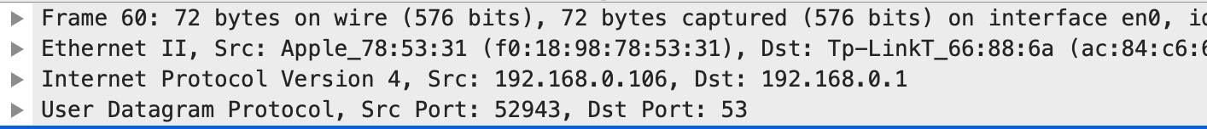

Цільовий порт: 53

Вихідний порт: 52943

1. На який адрес IP був відправлений запит DNS? Чи є цей адрес адресом локального сервера DNS?

IP:192.168.0.1, є адресом локального порта. 3.Проаналізуйте повідомлення із запитом DNS. Якого

«Типу» цей запит? Чи вміщує цей запит деякі можливі компоненти «відповіді»?

Цей запит – є запитом стандартного типу. Вміщує.



1. Дослідіть повідомлення із відповіддю DNS. Яка кількість відповідей запропонована сервером? Що вміщує кожна з цих відповідей?

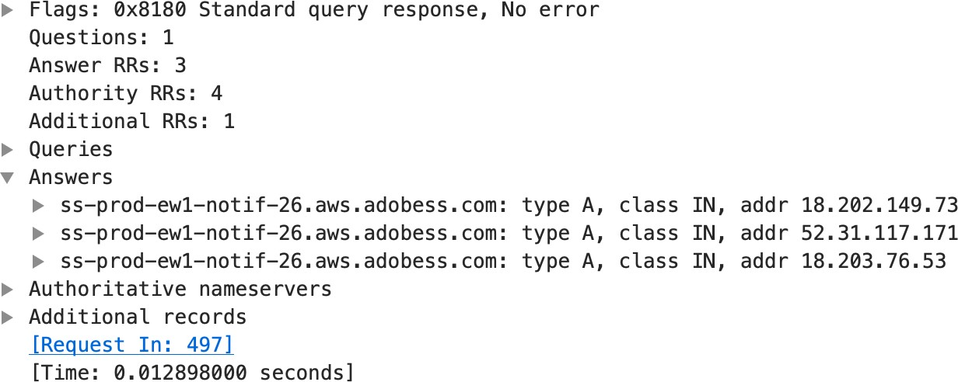

1. Проаналізуйте повідомлення TCP SYN, яке відправила ваша робоча станція після отримання відповіді сервера DNS. Чи співпадає цільова IP адреса цього повідомлення з одною із відповідей сервера DNS?

Так, співпадає



1. Чи виконує ваша робоча станція нові запити DNS для отримання ресурсів, які використовує документ, що отримав браузер?

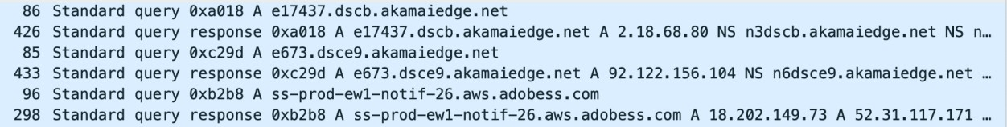

1. Яким був цільовий порт повідомлення із запитом DNS? Яким був вихідний порт повідомлення із відповіддю DNS?

Цільовий: 192.168.0.1

Вихідний: 192.168.0.106

1. На яку IP-адресу був направлений запит DNS? Чи є ця адреса адресою вашого локального сервера DNS за замовчанням?

192.168.0.1, є адресою локального сервера

1. Дослідіть повідомлення із запитом DNS. Якого

«типу» був цей запит? Чи вміщує цей запит деякі можливі компоненти «відповіді»?

Цей запит – є запитом стандартного типу. Вміщує.

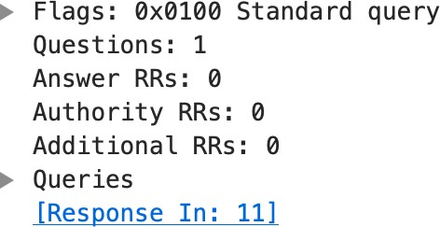

1. Дослідіть повідомлення із відповіддю DNS. Скільки записів із відповідями було запропоновано сервером? З чого складається кожна із цих відповідей?

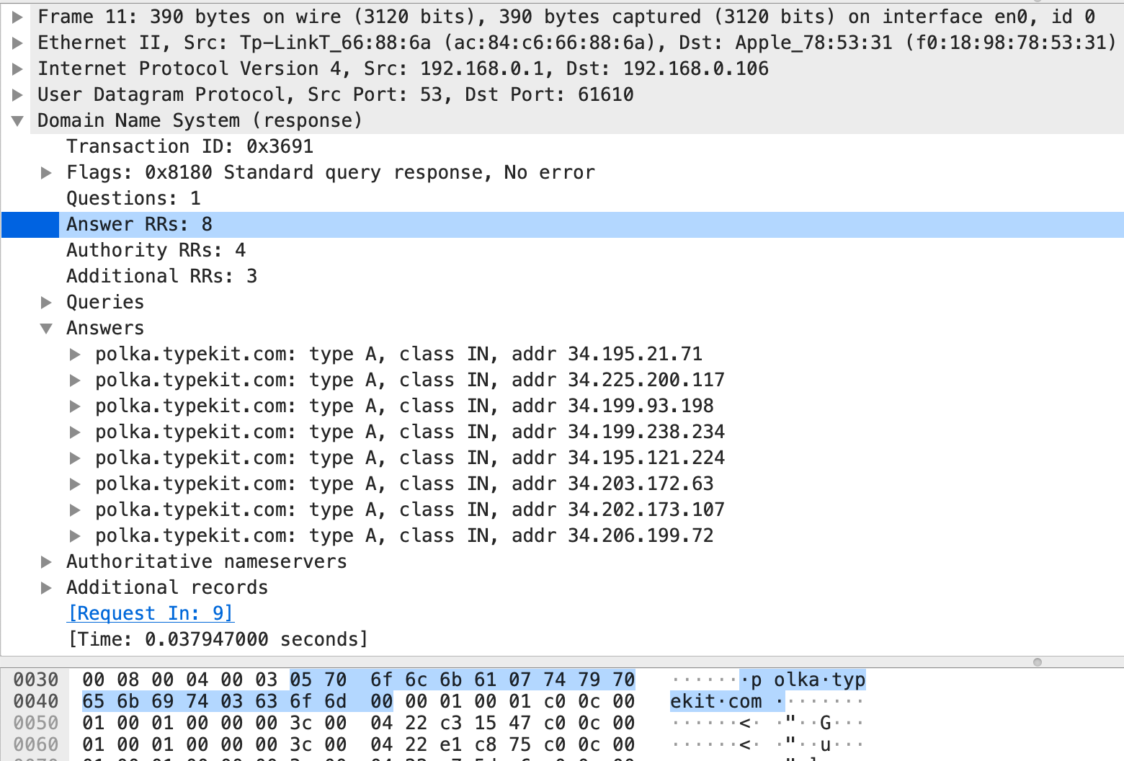

1. На яку IP-адресу був направлений запит DNS? Чи є ця адреса адресою вашого локального сервера DNS за замовчанням?

IP: 192.168.0.1. Так є.

1. Дослідіть повідомлення із запитом DNS. Якого

«типу» був цей запит? Чи вміщує цей запит деякі можливі компоненти «відповіді»?

Стандартний тип запиту. Так вміщує.

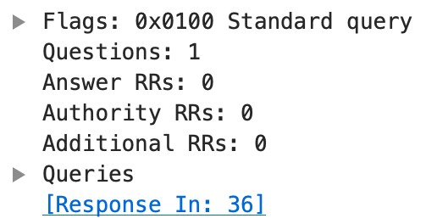

1. Дослідіть повідомлення із відповіддю DNS. Скільки

записів із відповідями було запропоновано сервером? Які сервери DNS були запропоновані у відповіді?

Сервери були запропоновані за допомогою доменного імені, адреси IP або й того й іншого?

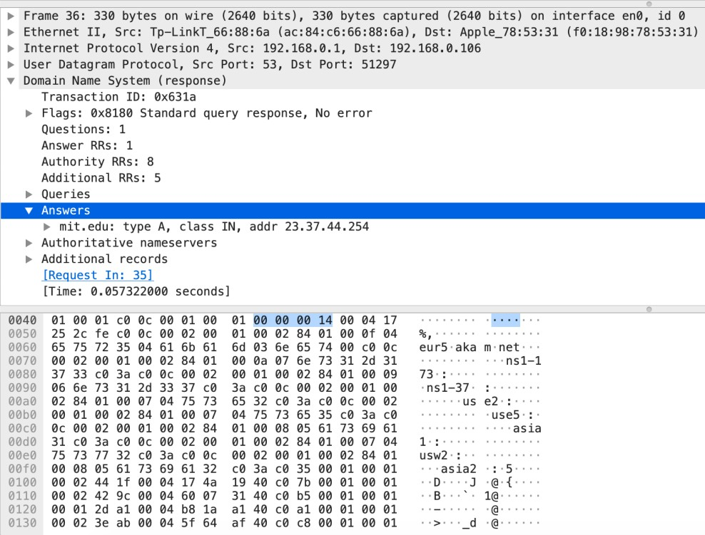

1. На яку IP-адресу був направлений запит DNS? Чи є ця адреса адресою вашого локального сервера DNS за замовчанням? Якщо ні, то якому доменному імені відповідає ця IP-адреса?

IP: 18.0.72.3. Не є адресою локального сервера.

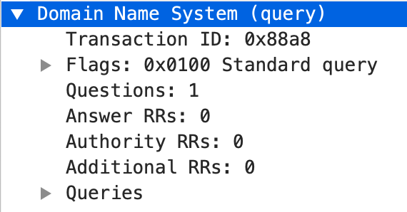

1. Дослідіть повідомлення із запитом DNS. Якого

«типу» був цей запит? Чи вміщує цей запит деякі можливі компоненти «відповіді»?

Стандартний тип запиту. Ні не вміщує.



1. Дослідіть повідомлення із відповіддю DNS. Скільки записів із відповідями було запропоновано сервером? З чого складається кожна з цих відповідей?

Відповідь не була отримана.

**Висновок:** В ході виконання даної лабораторної роботи, були покращено навички використання програми Wireshark для захоплення пакетів. Було проаналізовано протоколи DNS та було проведено аналіз деталей роботи даних протоколів.